**ETEC DE SAPOPEMBA – NOVEMBER -2020 – ENGLISH - Maria José S.D. da Costa**

**NOME: GABRIEL FALCÃO GAMONAL CARVALHO**

**TURMA:2ºI**

**CURSO: TÉCNICO EM DESENVOLVIMENTO DE SISTEMAS**

**DATA: 01/12/2020**

**ACTIVITY ABOUT REFLEXIVE PRONOUNS:**

**A – Complete with each other / one another or reflexive pronouns ( myself, himself, etc.)**

1. My sister and I help each one with our homework.

2- My boyfriend and I love each another _ _.

3- The children made_ each another _dinner because their mother was woking. 4- I met a mano n the bus. We talked to each one _during the whole trip.

**5-** We enjoyed_ each another _ at the party because all our friends were there.

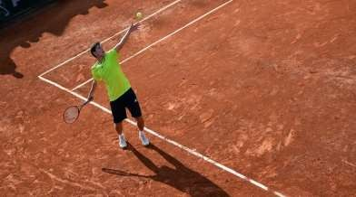

**B**- **Complete this text about a professional tennis player. Use reeflexive pronouns or each other / one another.**

I am a professional tennis player.

I taught each one how to play tennis because my parentes didn’t think sport was a good profession. Every day, I have a similar routine.

I Wake up early and make_ each another _breakfast. Then I meet my coach on the tennis court and we train with each another__for about four hours.We stop at about 12:30 and make each one _lunch. Then we train for another four hours in the afternoon. I love my profession but I often worry yhat I will hurt_ each one during training.